Nutritional Farming As
Opposed To Organic Farming
(Naturally Growing Nutritionally Super Enriched Food)

by
Pramod Vora, Holistic Educator & Natural Health Counselor to Doctors
E-mail: sac@space-age.com
Web: www.space-age.com

Paper Presented at:

International Conference on Alternative Medicine,
Ministry of Health & Family Welfare, New Delhi
at
Tamil Nadu Agricultural University, Coimbatore
on March 16th to 19th, 2006

SpaceAge ®

Natural Health Center
92 Corporate Park, Ste. C #705,
Irvine, CA 92606 USA
Tel: +1 - 949 - 861 - 8164
========================================
# 9/123 Marol Co-op. Industrial Estate
Marol Sagbaug, Andheri (E), Mumbai 400 059 India
Tel: +91 – 22 - 2850 - 3986 / 2850 - 8653
Fax: +91 - 22 – 2850 - 6214
E-mail: sac@space-age.com
Internet: www.space-age.com

Innovations in Alternative
Agricultural Technologies!

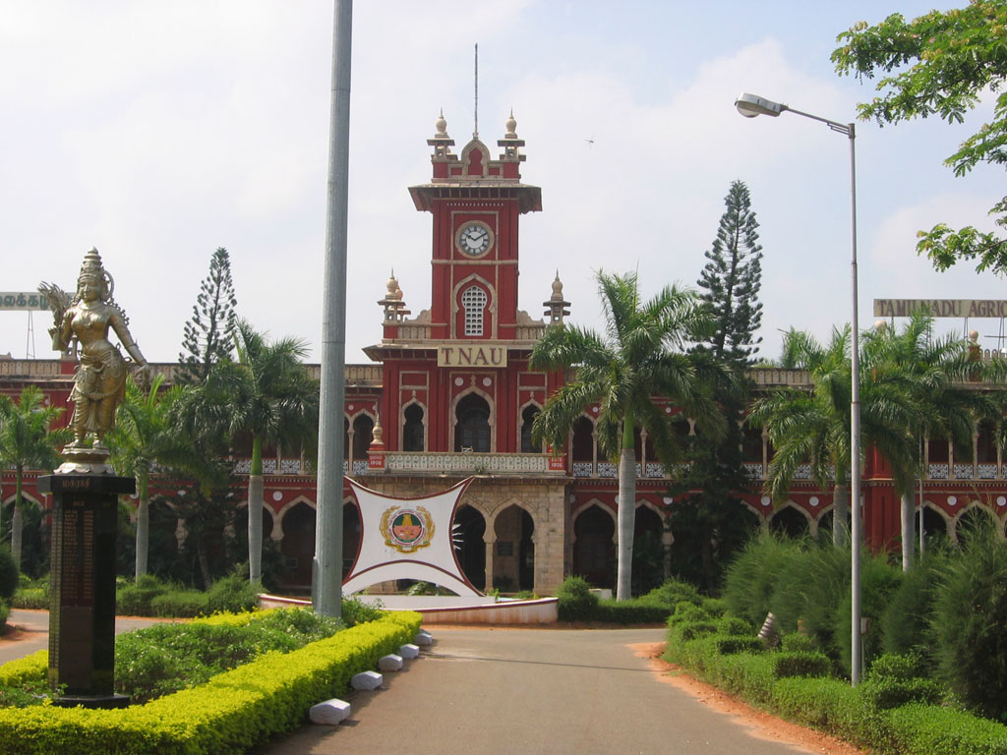
TNAU - Tamil Nadu Agricultural University, Coimbatore Campus
University originally establish in 1868
The oldest Agricultural University in Asia

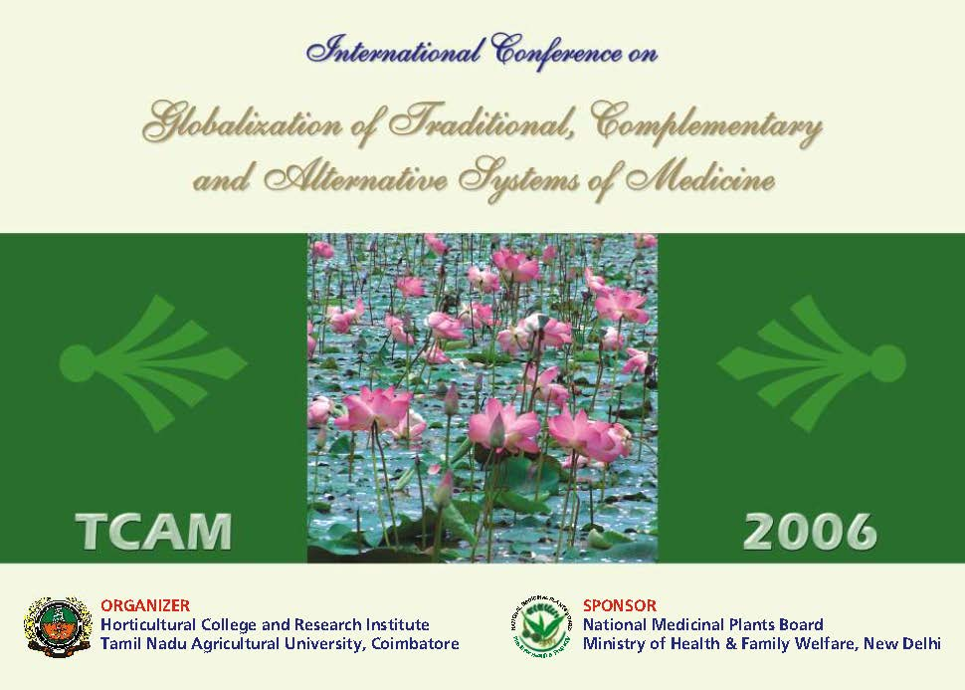

Abstract on:

Nutritional Farming – As Opposed To Organic Farming
(Naturally Growing Nutritionally Super Enriched Food)

Over cultivation of land and the rampant use of synthetic fertilizers has resulted in crops with extremely poor nutritional / medicinal value. Mineral / Nutritional deficiencies documented by the research done a few years back at the Rutgers University in New Jersey, USA have highlighted this problem. The United State Department of Agriculture has documented “Shrinking Nutritional Value” over a 21 year period from 1976 to 1997. This reflects a tremendous fall in medicinal value for all crops.

These findings are extrapolated to medicinal plants, Aromatherapy, Ayurveda and Siddha Medicine.

Ecological damage due to the construction of dams has affected the lives of billions of people around the world. The importance of periodic floods and silt brought down by rivers has been emphasized.

Correlation between the nutritional / medicinal value of crops and chronic ailments like old age diabetes, high blood pressure, heart disease, etc. is brought out.

Natural methods to correct the depleted soil to ensure the same nutritional / medicinal value as existed 50 to 100 years back before the advent of synthetic fertilizers is explained.

India and the rest of the world need to leapfrog into “Nutritional Farming as opposed to the organic farming” concept being actively popularized today. Organic farming on depleted soil can only result in crops with poorer nutritional / medicinal value.

Caution needs to be exercised when encouraging the conversion of expended agricultural farm land to growing of medicinal plants.

Recommendations are made for further research and for Government Authorities to wake up to this alarming situation which has affected the life of billions of people in India and worldwide. The need to certify nutritional / medicinal value (active ingredients) of crops is the need of the hour.

by
Pramod Vora, Director
SpaceAge Concepts (India) Ltd.
9/123 Marol Co-operative Industrial Estate
P. O. Box 7432
Andheri (East), Mumbai 400 059 India
Tel: +91 – 22 - 2850-3986 / 2850-8653
Fax: +91 – 22 – 2850-6214
E-mail: sac@space-age.com
Web: www.space-age.com
Nutritional Farming – As Opposed To Organic Farming
(Naturally Growing Nutritionally Super Enriched Food)
by
Pramod Vora, Director
SpaceAge ® Concepts (India) Ltd.
9/123 Marol Co-operative Industrial Estate
Marol Sagbaug, Andheri (E), Mumbai 400 059
Tel: +91 – 22 - 2850-3986 / 2850-8653
Fax: +91 - 22 - 2850 -6214
E-mail: sac@space-age.com
Internet: www.space-age.com/magwater/

If you look at all the great civilizations of the world during the past few thousand years, like the Indus Valley Civilization, the Egyptian Civilization on the Nile we find one common denominator. They all came up on the banks of a great river. The civilizations grew and prospered because of the fertility of the land on the banks of the river. The crops grown were very good and people were healthy and strong and the population multiplied steadily.

Having said this about the Earth, let us now move on to the Solar System and the Universe.

The Universe is a perfect place. To appreciate the perfection of the Universe, one needs to look up at the sky and appreciate the mathematical precision with which the planets and stars move. You can predict their exact location 10,000 years BC and 10,000 years AD.

Once we begin to appreciate the perfection in the Universe, we begin to have a new respect for nature and also understand the limitations of our own scientific knowledge and our comprehension of the working of the mechanism of our Planet Earth.

Mother Earth has a perfect method of ensuring the health of mankind and the evolution of the human race which it successfully did for thousands of years. The river valleys were fertile lands where crops of good quality grew. With the flowing waters of the river, silt (potent natural fertilizer) was brought down from the mountains to replenish the soil depleted due to repeated cultivation of the land on the banks of the river.

As more food was grown and the soil was further depleted, the rains came and periodically brought “good floods” with them which helped to efficiently remove the depleted top soil and the running waters of the rivers brought in fresh silt or potent natural fertilizer to replenish the soil.

This continued for thousands of years without fail and the human race prospered and grew.

Then one fine day it all stopped. Why?
The engineers from Ivy League Colleges decided to use their intellect and knowledge to build dams to prevent “bad floods” and harness the energy of the flowing water to generate electrical energy!

That was the greatest ecological disaster of modern times that can ever be imagined. It has inadvertently affected the lives and health of billions of people today. These engineers had no knowledge or appreciation of the perfection of nature and how the mechanism of Mother Earth operates. It was like giving the controls of a jet plane to a truck driver. The results will only be disastrous and so they were.

Today, the silt (potent natural fertilizer) does not come down the mountains any more, the floods have stopped due to the construction of the dams and the soil is completed depleted of its potency. The human race is suffering from chronic ailments all through their adult life and is prematurely dying of these chronic ailments. It is time we woke up now to this man made disaster in our life which has reached pandemic proportions and is far greater in magnitude than SARS or the much talked about Avian Bird Flu.

More money is being ear marked for putting up more hospitals and beds and educating more doctors. Soon we will need one hospital bed for each person living on this Earth. All this because we fail to realize that we have tampered with the Perfection of Mother Nature and worked against nature, than in harmony with it.

Today, after 50 years of use of NPK fertilizers (nitrogen, phosphorous and potassium) the nutritional value of food is less than 25% of what it used to be 50 years back. Surprised? Well as the information that follows will prove beyond doubt that this is a very conservative estimate in order not to shock you into the ICU.

The human body needs calcium, magnesium, zinc, iron, boron, chromium, selenium, etc. (to name a few) to function properly. Lack of any one element causes chronic ailments. The NPK synthetic fertilizers do not replace these essential elements required by the human body. The soil is depleted and now the human race must suffer from osteoporosis, hypertension, diabetes, heart disease, obesity (to name a few serious ones) and a plethora of other chronic ailments while they are alive.

If the soil is depleted of say magnesium, the grass will not have it; if the grass does not have it, the cows will not get it; and if the cows do not get it, the cow dung will not have it; and if cow dung does not have it organic farming with cow dung cannot replenish the magnesium back into the soil nor can the crops grown with it have it.

Now you will have plants, animals and human beings all deficient in magnesium which is the prime cause of all cardiac diseases including high blood pressure.

The same logic will apply even if we used other organic materials, leaves and man made compost for organic farming.

Organic farming though a small step in the right direction is not the real solution to good health and longevity.

We need a new concept called Nutritional Farming to replace organic farming. India and the whole world needs to leapfrog into this new technology of Nutritional Farming.

More than a 15 years back while the concept of organic farming was still in its infancy, an educated engineer turned farmer came to my office with a bag full of organic rice grown at Kamshet in Western Maharashtra. He told me that he had never used synthetic fertilizers, herbicides and pesticides on his farm and his was virgin land. As you know the western region of Maharashtra receives about 100 inches of rain each year. He proudly told me this was the best organic rice in the whole world.

I decided to conduct an experiment and asked him to get similar rice from the neighboring farmland right adjacent to his. Now we took a sample from each lot and send them for nutritional testing. I was shocked at what I saw when the reports came in. The rice from the neighboring farmland grown with synthetic fertilizer had better nutritional value than his organic grown rice. It had more magnesium, more phosphorous and more iron to name a few. The rice was tested before polishing in order to access its nutritional value properly. His organically grown rice did not meet the standard text book nutritional values of rice. The farmer went away crest fallen. But this set me thinking. This is how research into nutritional farming began in our Labs in early 1990 about 15 years back.

The questions now arise:
Why do I need Nutritional Farming?

If your land yields poor tonnage per acre, it could be due to:
- Over cultivation of the land?
- Poor soil pH?
- Flooding due to extremely heavy rains?
- Excessive use of fertilizers in the past?
- Poor nutritional / mineral soil content?

How is Nutritional Farming useful?

- Due to over cultivation of land and the use of synthetic fertilizers, the nutrition in the soil has gone down tremendously
- As a result the nutritional / medicinal value of food / produce / herbs and medicinal plants has also gone down substantially.

What is the lay man’s test to determine poor nutritional value?

- Poor taste = Poor nutritional value
- Weak & sick plant = Poor nutritional value
- Diseased plants / crops that constantly require pesticides and antibiotics to survive = Poor Nutrition Value

Let us now analyze the findings of the Rutgers University in New Jersey, USA on mineral content of food.

MINERAL COMPARISON OF FOODS GROWN ORGANICALLY VS. CONVENTIONAL CHEMICAL (SYNTHETIC FERTILIZER) PRODUCTION

Snap Beans Cabbage Lettuce Tomatoes Spinach

Calcium {Org. 40.5 60.0 71.0 23.0 95.0 {Con. 15.5 17.5 16.0 4.5 47.5

Magnesium {Org. 60.0 43.6 49.3 59.2 203.9

{Con. 14.8 15.6 13.1 4.5 45.9

Potassium {Org. 99.7 148.3 176.5 148.3 257.0

{Con. 29.1 53.7 53.7 58.6 84.0

Sodium {Org. 8.6 20.4 12.2 5.5 59.5
{Con. 0.0 0.8 0 0 0.8

Manganese {Org. 60 13 169 68 117
{Con. 2 2 1 1 1

Iron {Org. 227 94 516 1938 53
{Con. 10 20 9 1 0

Copper {Org. 69 48 60 53 32
{Con. 3 0.4 3 0 0.5

The amount of each chemical element is expressed in milligrams per 100 grams dry weight for the first four elements, then in parts per million for the three trace elements. The above Table is based on research at Rutgers University, NJ, USA.

The published results of this experiment show that the mineral elements calcium, magnesium, potassium, sodium, manganese, iron and copper were far more abundant in the five garden vegetables raised by organic methods on organic / nutritionally rich soil than the same vegetables raised by commercial methods generally used to grow produce for market on over cultivated farm land treated with synthetic fertilizer.
Commercially grown vegetables had only 13% of the mineral elements than organically / nutritionally grown vegetables. This means that to obtain the same mineral content you will have to eat 7 commercial tomatoes to get the nutrition of 1 organically grown tomato. This is physically impossible to do!

What is the prime cause of Chronic Diseases?
- Numerous chronic diseases – hypertension, old age diabetes, heart disease to name a few, that we see today are a result of the poor quality / nutritional value of food that our country produces on over cultivated land previously treated with synthetic fertilizer.
- Symptoms of diseases / imbalances in the body will therefore not effectively respond to aromatherapy or herbs grown on land with poor nutritional value.

How can we correct this problem?

- This problem can only be solved by first correcting the soil conditions and changing over to nutritional organic farming i.e. farming without the use of synthetic fertilizers, herbicides and pesticides as compared to pure organic farming.
- Organic farming on poor land can only yield crops with lower nutritional / medicinal value. So herbs / aromatherapy do not work effectively.

Let us analyze the finding of the US Department of Agriculture about the “Shrinking Value of Nutrition” in food.

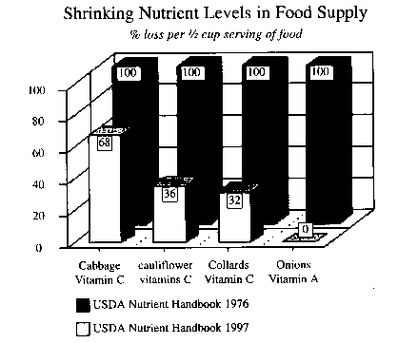

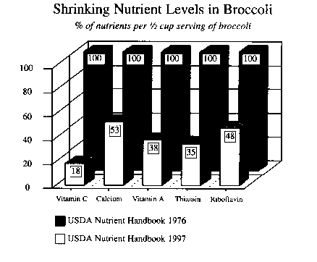

Can Organic Farming be the solution?
- Organic farming alone will not help to improve the nutritional / medicinal value of the food grown in the world since the soil is already seriously depleted. The construction of dams has prevented the deposition of fresh silt and the removal of depleted top soil, by a natural process called floods. This has created an ecological disaster and subjected mankind to chronic ailments and premature death. In this case the use of herbs / aromatherapy will not be very effective.

Organic Farming on depleted soil does not make much sense.

- The need of using organic micronutrients to build up the strength of the soil is of primary importance today. Once the soil conditions are improved, organic farming will help to prevent further damage to the soil, and to improve the nutritional value of the Ffod we eat / medicinal value of plants used in Aromatherapy, Ayurveda and Siddha medicine.

Damage due to 50 years of synthetic fertilizers.

- It is now obvious, after 50 years of use of synthetic fertilizers, that they damage the land, reduce the nutritional value of the crop and cause a host of chronic ailments. synthetic fertilizer only replenish nitrogen, phosphorous and potassium in the soil. With each crop cycle other essential minerals like magnesium, calcium, zinc, manganese, boron, iron, chromium, vanadium, selenium etc. get depleted. This causes low immunity of the crops and the need to use pesticides, herbicides and antibiotics seems necessary.

What can we do about it?

- Since the soil is depleted of essential minerals and lacks nutritional value, a technique has to be found to correct this naturally – through the use of naturally occurring substances.

What are the Natural Sources?
- The following rocks are a rich source of:
- Barite – for boron
- Bauxite – for iron, silicon
- Calcite – for calcium
- Dolomite – for calcium, magnesium and iron
- Feldspar – for potassium and silicon
- Chromite – for chromium and iron
- Manganite – for manganese
- Volcanic Ash – for all elements of the Periodic Table

How to add these to the soil?

- Watch and observe nature at work and learn from its infinite wisdom and perfection.
- Do exactly as the flowing waters of the rivers do.
- Crush these naturally occurring rocks from the mines and add them to the soil
- You can literally return your land back to the same rich condition as it was a million years ago.

What else can we do?

- Begin dismantling the dams which have damaged the ecology and the health of the nation and billions of people worldwide. This process has already begun in the US.
- Begin praying for periodic floods, so that the depleted top soil can be removed more efficiently and fresh silt can be deposited from the virgin mountain tops.
- Use Bio-Magnetics to improve the yield of the land.

Bio-Magnetics To The Rescue

- Water Conditioning Technology helps to naturally enhance the yield of the land, without use of synthetic fertilizer. Magnetic Water Conditioners are a perfect fit for those farms equipped with drip irrigation or sprinkler systems. This technology, will increase the yield per acre, result in healthier crops, larger fruits and flowers and will also ensure proper delivery of water day after day by preventing and dissolving the calcium deposits on the jets, nozzles and sprinkler heads of the water system used to irrigate the land. It does not deprive the land of beneficial minerals that come along with the irrigational water. Water Conditioning Technology can also be used for Soil Desalination and to repair land damaged by the excessive use of synthetic fertilizers.

Magnetic Treatment of Seeds
- Magnetic Treatment of Seeds helps improve their quality, germination properties and their rate of growth during germination. Magnetic treatment of seeds must be done before sowing through the use of a Magnetic Funnel. Such treatment can be done with soaked or unsoaked seeds.

The Procedure
- Take a Magnetic Funnel and a container to soak the seeds. Pour water required for soaking seeds through the funnel into the container. Then pass the seeds through the magnetic funnel. Thereafter soak the magnetically treated seeds in the magnetically treated water in the container for about 1.0 hour. Pour out the water and pass the soaked seeds through the magnetic funnel once again. These seeds are now ready for sowing.

The Procedure for Bulk Seeds

- To apply the above procedure to a very large number of seeds required to plant in a field, it is necessary to modify the above procedure as follows:
- Pass fresh seeds through the magnetic funnel before sowing, thereafter use only magnetic water for irrigation of the field.
- Both these procedures will show noticeably improved results.

Soil Desalination

- Magnetic treatment of water makes it possible to use salty water for irrigation of different agricultural crops. It also helps to wash out the salts from the soil.
- When salts accumulate in the soil, its capacity to grow crops is seriously hampered as the capillaries of the soil get choked up. This in turn causes less nutrition to reach through the capillaries in the roots to the plant leading to its eventual death. Magnetically treated water can help to desalinate the soil.
- Magnetic treatment of water improves 3 to 4 times it ability to dissolve solids which helps in the desalination of the soil. Magnetically treated water helps to break up larger crystalline salts (formed due to excessive use of fertilizer) and nutrition into smaller particles which the plant roots can absorb easily. This leads to healthy plants and better yields. Magnetic treatment of soil results in earlier harvesting and minimizes the use of fertilizers and irrigational water.

Goal of Nutritional Organic Farming
- Correcting soil conditions to improve the nutritional value (quality / taste) of the food / medicinal value of the plants grown in our farms should be the primary goal of the modern day farmer. Increasing nutrition to the human body through good quality nutritious food / medicinal plants is a simple low cost solution to free the body of chronic ailments and to achieve a long and healthy life.
- Agricultural methods and goals of farming need to be modernized for the good of mankind.
- The use of Bio-magnetic technologies in farming, is the preferred method of agriculture, as it is totally natural (works in conjunction with the Earth's magnetic field which has gradually depleted) and does not use synthetic fertilizers / chemicals. Agriculturally advanced countries like Israel, Russia and America have taken lead in this direction.
- Correcting the mineral / nutritional deficiency of the soil is the first step to Nutritional Organic Farming and a long healthy life free from disease for all mankind.

Goals for the World

- We need to save some money ear marked for health care and invest in Nutritional Farming and Certifying the Nutritional Value of food and the medicinal value (active ingredients) of plants.
- Investing wisely in Nutritional Farming / Agriculture will save in health care costs in the long run.
- Any amount of money spent on health care will be a “Mission Impossible”. No one can provide a bed in a hospital for every person in the world. It is financially impossible!
- India and the rest of the world need to leapfrog into Nutritional Farming as opposed to organic farming concept being actively promoted today. Organic farming on depleted soil can only result in crops with poorer nutritional / medicinal value.
- Caution needs to be exercised when encouraging the conversion of expended agricultural farmlands to medicinal plant farms.

Recommendation for further Research

- Use of Natural Sources of mineral deposits to reactivate the land to correct nutritional value of land.
- Standards to be developed for certifying medicinal value of plants.
- Standards to be developed for certifying the nutritional value of food.
- Further research in Bio-Magnetics to increase the yield per acre to enable farmers to economically move over to organic / nutritional farming and to enable the production of low cost organically / nutritionally grown food / medicinal plants.
- Work needs to be seriously started on the modernization of Ayurveda / Siddha in keeping with the ecological problems being faced by the masses today.

Recommendation to the Government Authorities
- We cannot keep on buying food by weight alone. This is as foolish as buying brass at the price of pure gold.
- There should be an agency to certify the nutritional value of food grown just as there are bodies that certify organic food.
- Organically grown food / plants do not guarantee its nutrition or medicinal value.
- It is pointless for the country to spend more on adding beds, hospitals and doctors. If we continue doing this we will soon need a bed for every person in the world.
- Proper nutritional food / medicinal herbs will ensure the need for minimal number of beds, hospitals and doctors in the country.
- The manufacture and sale / advertising of single, double and triple refined salt and sugar should be banned as important minerals required by the human body are removed in the process of refinement. The whole concept of the Dandi Yatra movement of Mahatma Gandhi needs to be revived so that people can begin eating natural sea salt rich in minerals.
- For similar reasons the sale of reverse osmosis units for purification of drinking water for domestic use should be banned.
- The Government should recognize the importance and separately classify all types of dietary supplements – herbal and nutritional so as to encourage its free Over The Counter (OTC) sale as non prescription drugs. This would be in keeping with the norms of other countries like USA, Canada and Europe. Turmeric, Ginger and Saffron to name a few, should not be classified as Ayurvedic Medicine but strictly as food items.
- Caution should be exercised when sanctioning any more projects for the construction of dams and their impact on the health of the people. Dams which have completed their life span and need to be rebuild should be summarily dismantled.

by
Pramod Vora, Director
SpaceAge ®
92 Corporate Park, Ste. C, #705
Irvine, CA 92606
USA
Tel: +1 - 949 - 861 – 8164
Fax: +1 - 949 - 861 - 8165
E-mail: sac@space-age.com
Internet: www.space-age.com/magwater/

INNOVATORS IN ALTERNATIVE AGRICULTURAL TECHNOLOGIES !

References:

- The Survival of Civilization, John Hamaker
- Bread from Stones - A New and Rational System of Land Fertilization and Physical Regeneration (1894) by Julius Hensel
- To Love and Regenerate the Earth by John Hamaker
- METHOD AND APPARATUS FOR THE AUTOGENOUS CRUSHING OF STONE AND THE LIKE by John Hamaker
- Modern Miracle Men by Dr, Charles Northen, United States Senate Document No. 264 presented at the 74th Congress, 2nd Session, June 1936
- Sea Energy Agriculture by Dr. Maynard Murray, M.D. 1976
- The Healing Power of Minerals, Special Nutrients and Trace Elements by Paul Bergner. Bergner is the clinic director of the Rocky Mountain Center for Botanical Studies, and editor of Clinical Nutrition Update and Medical Herbalism newsletters.

D. W. Cavanaugh, M.D., Cornell University:
"There is only one major disease and that is malnutrition. All ailments and afflictions to which we may fall heir are directly traceable to this major disease."
Simply stated, food crops grown on depleted soil produce malnourished bodies, and disease preys on malnourished bodies.

© Copyright 1990 - 2013 SpaceAge ®. All Rights Reserved.

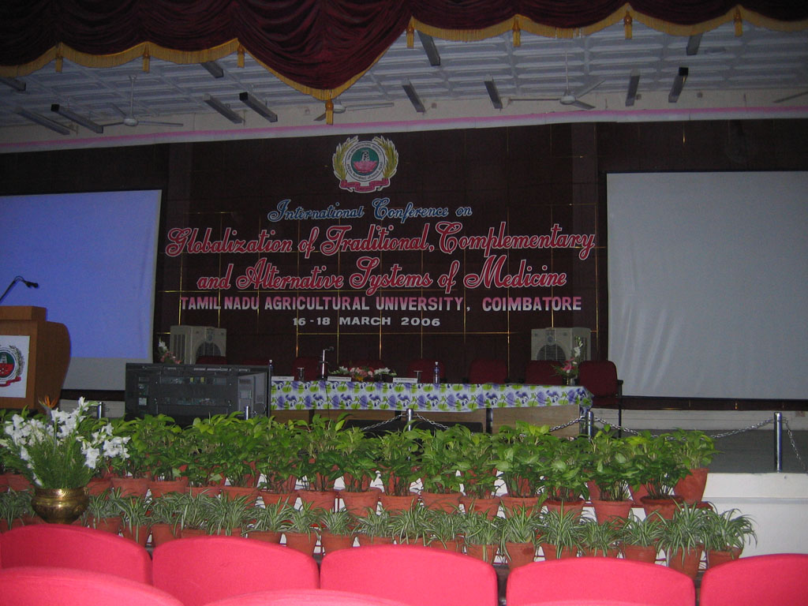
The Conference on Alternative Medicine

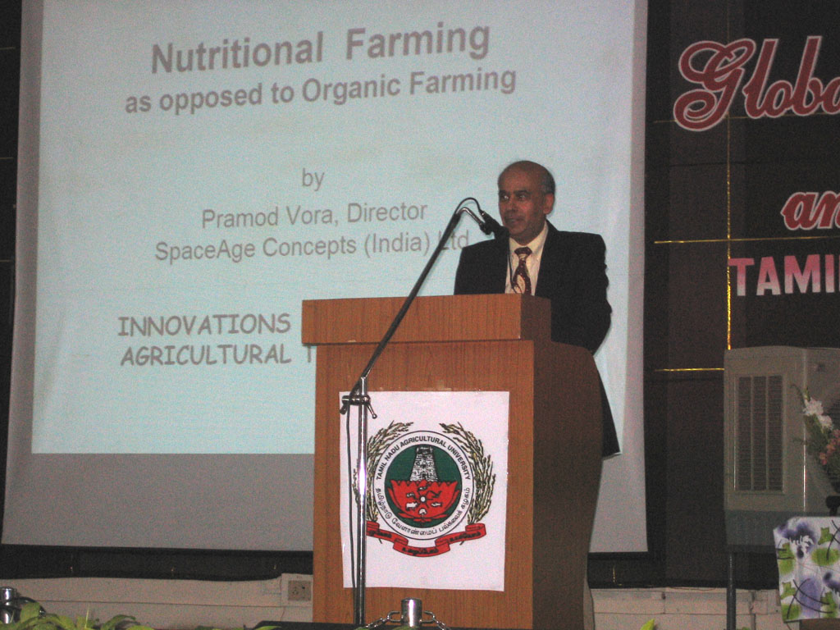
Nutritional Farming - I

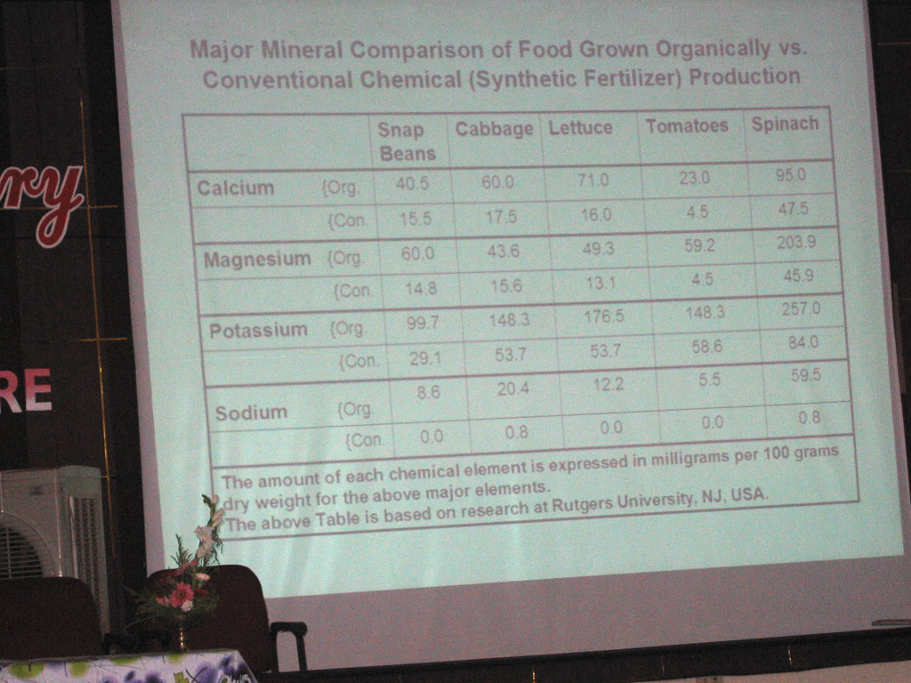
Nutritional Farming - II

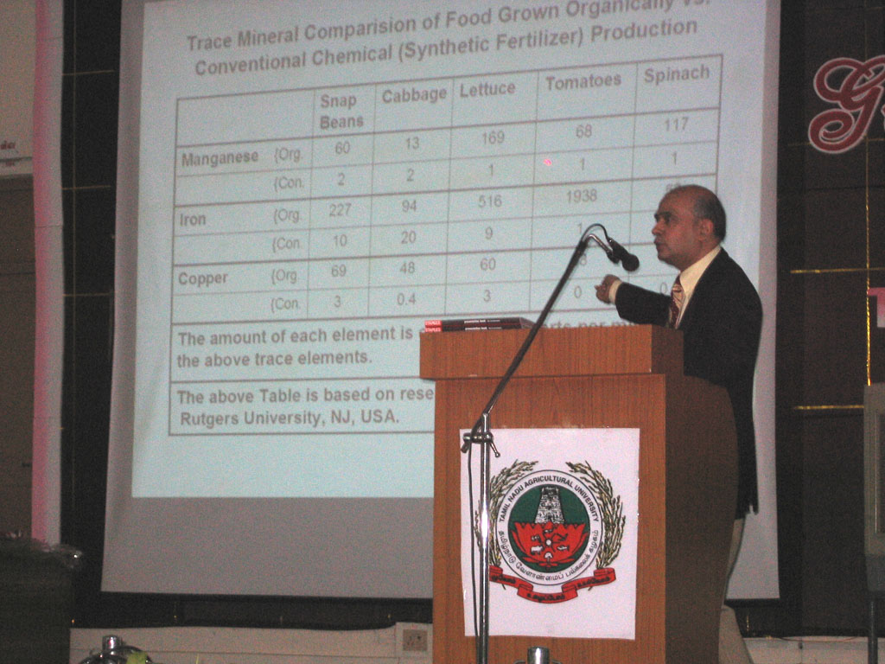
Nutritional Farming - III
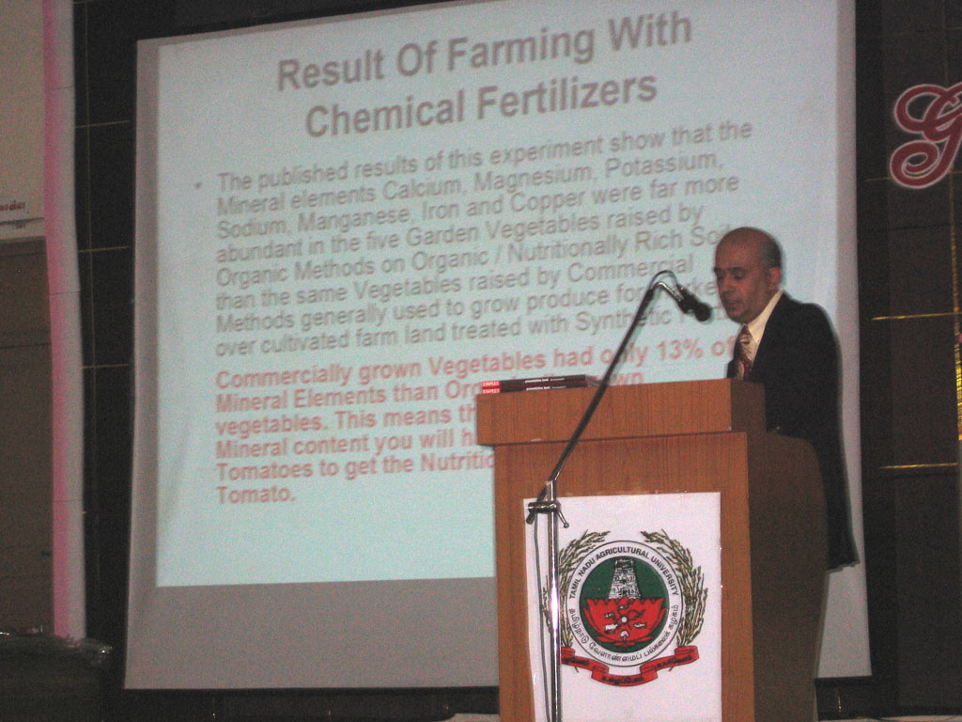
Nutritional Farming - IV

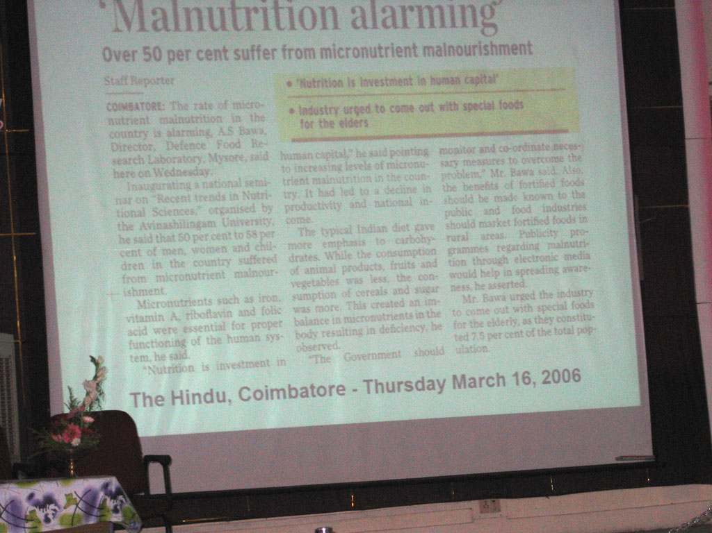
Malnutrition in India
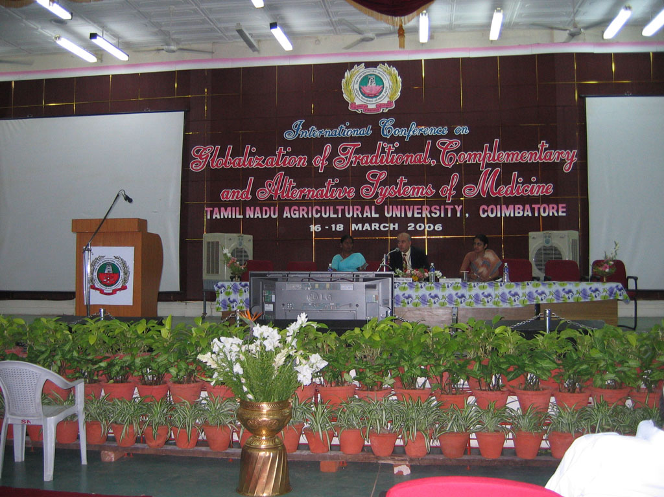
Chairing Session 6 on "Global Opportunity &
Need of Herbal Health Foods

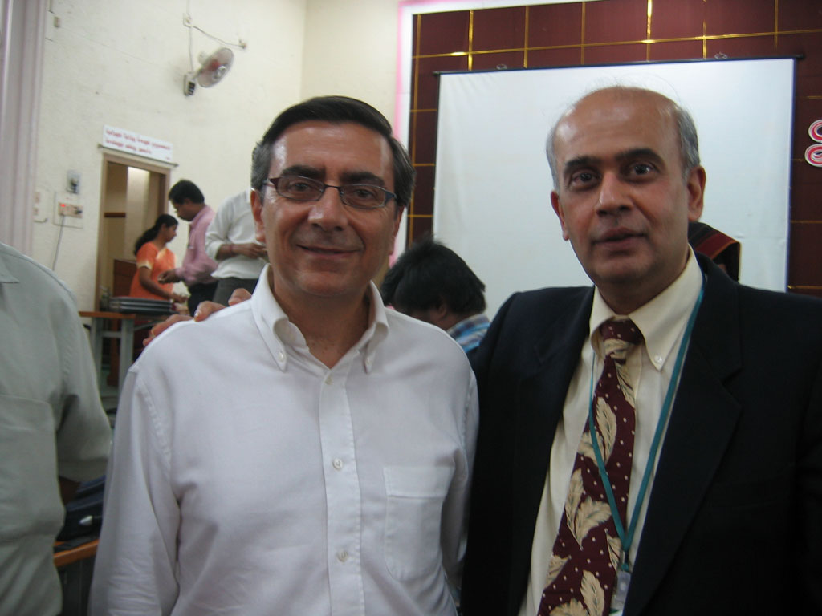
Dr. Gerry Bodekar - Editor-in-Chief, WHO
Global Atlas with Pramod Vora
Words of Encouragement & Appreciation


Dr. Gerry Bodekar
Dear Pramod,

Keep up the good work for Nutritional Agriculture - an easy
concept to get when one hears it, but easy to miss if one
doesn't.

Best regards to you and your wife,
Dr. Gerry Bodeker
Editor-in-Chief
WHO


Dr. E Vadivel
I thank whole heartedly for the vibrant and expressive presentation delivered by you.

Dr. E. Vadivel,
Director
TNAU

© Copyright 1990 - 2013 SpaceAge ®. All Rights Reserved.
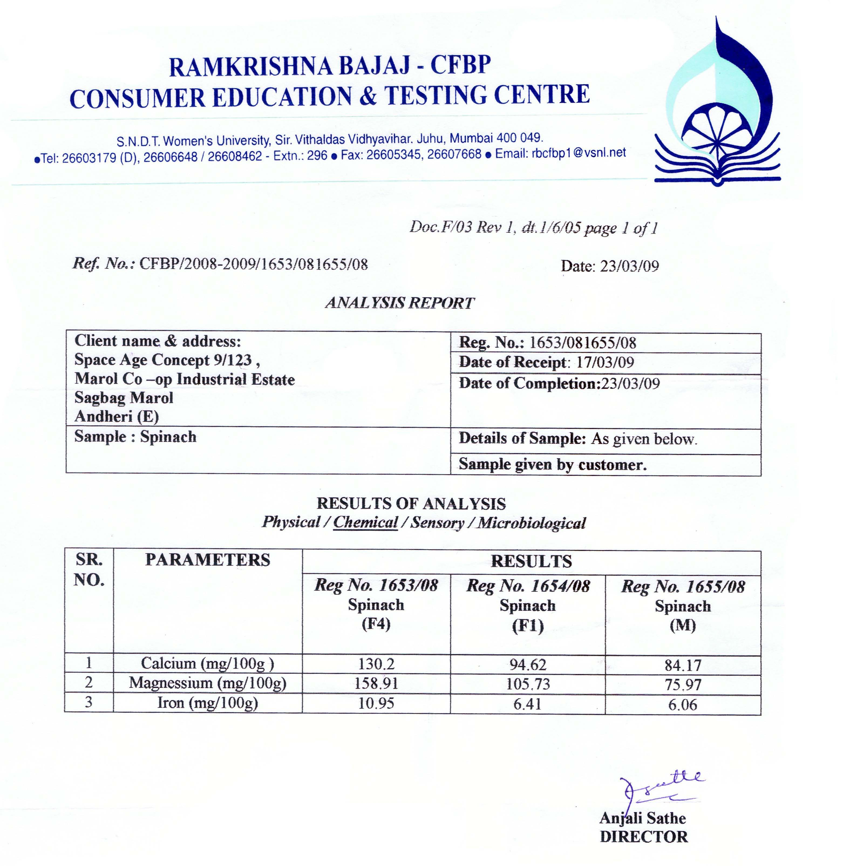

Notes added for further research work:

1) Sample M = Random sample from grocery store commercially grown with NPK fertilizer.

2) Sample F1= Spinach grown with organic manure prepared from cowdung.

3) Sample F4= Spinach grown with nutritional soil correction (remineralization) + biomagnetic treatment of water + cowdung manure. This has resulted in growing of “Nutritionally Super Enriched” spinach with nutritional levels well above the standard textbook nutritional levels given by USDA.

Observation:
Spinach grown using the principles of Nutritional Farming (soil remineralization + biomagnetics) had almost double the amount of iron, calcium and magnesium compared to commercially available spinach grown using NPK fertilizer.
Justus von Liebig (1803-1873)

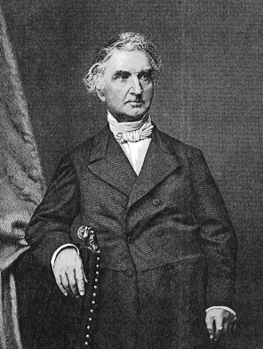

Justus von Liebig (May 12, 1803 in Darmstadt, Germany - April 18, 1873 in Munich, Germany) was a German chemist.

Organic Chemistry in its Application to Agriculture and Physiology.
by Justus Von Liebig - 1840

It is probably one of the biggest mistakes in the history of mankind convincing farmers that NPK type fertilizers is the way to go. Justus Von Liebig in 1840 wrote Organic Chemistry in its Application to Agriculture and Physiology. Later he repents on his big mistake causing chemical companies to take over and push NPK fertilizers that wind up killing the soil, growing poor quality food and causing a degeneration of health in mass humanity.
Von Liebig even said later:
"I had sinned against the wisdom of the Creator, and received my righteous punishment. I wished to improve his work, and in my blindness believed that, in the marvelous chain of laws binding life on earth’s surface and keeping it always new, a link had been forgotten which I, weak and powerless worm, must supply."
—Justus von Liebig, late in life
Quoted from Encyclopedia Britannica, 1899.
(removed from subsequent editions).

Expert Opinion

“A declining soil fertility, due to a lack of organic material, major elements, and trace minerals, is responsible for poor crops and in turn for pathological conditions in animals fed deficient foods from such soils, and that mankind is no exception.”

“NPK formulas, as legislated and enforced by State Departments of Agriculture, mean malnutrition, attack by insects, bacteria and fungi, weed takeover, crop loss in dry weather, and general loss of mental acuity in the population, leading to degenerative metabolic disease and early death.”

Dr. William A. Albrecht, Chairman of the Department of Soils at the University of Missouri.

1992 Earth Summit Statistics
1992 Earth Summit Report indicate that the mineral content of the world’s farm and range land soil has decreased dramatically.
Percentage of Mineral Depletion From Soil During The Past 100 Years, By Continent:
North America | 85% *
South America | 76%
Asia | 76%
Africa | 74%
Europe | 72%
Australia | 55%
* Some U.S. farms are 100% depleted and some are 60% depleted, the average is 85% depletion as compared to 100 years ago. This is worse than in any other country in the world because of the extended use of fertilizers and “maximum yield” mass farming methods.
“In the future, we will not be able to rely anymore on our premise that the consumption of a varied balanced diet will provide all the essential trace elements, because such a diet will be very difficult to obtain for millions of people.”
Dr. Walter Mertz, U.S. Department of Agriculture, told to congress in 1977.
“You can trace every sickness, every disease, and every ailment to a mineral deficiency.”
Dr. Linus Pauling the two-time Nobel Prize winner.
“In the absence of minerals, vitamins have no function. Lacking vitamins, the system can make use of the minerals, but lacking minerals vitamins are useless.”
Dr. Charles Northen, MD
“Minerals are certainly as important to us as vitamins, yet minerals are overlooked, neglected and their value underestimated.”
Gaylord Hauser, from his book, “Diet Does It”
Our illnesses are correlated with our improper stewardship of the land. Our immunity very much parallels the immunity of the land. Of special mention is that trace minerals are much depleted in our soils. Veterinarians have long since known this, which is why there are some 45 trace minerals added to dog and livestock food. They would much rather spend a few cents everyday than hundreds of dollars on vet bills!
Dr. Jensen’s book, Empty Harvest

© Copyright 1990 - 2013 SpaceAge ®. All Rights Reserved.

Some Testimonials
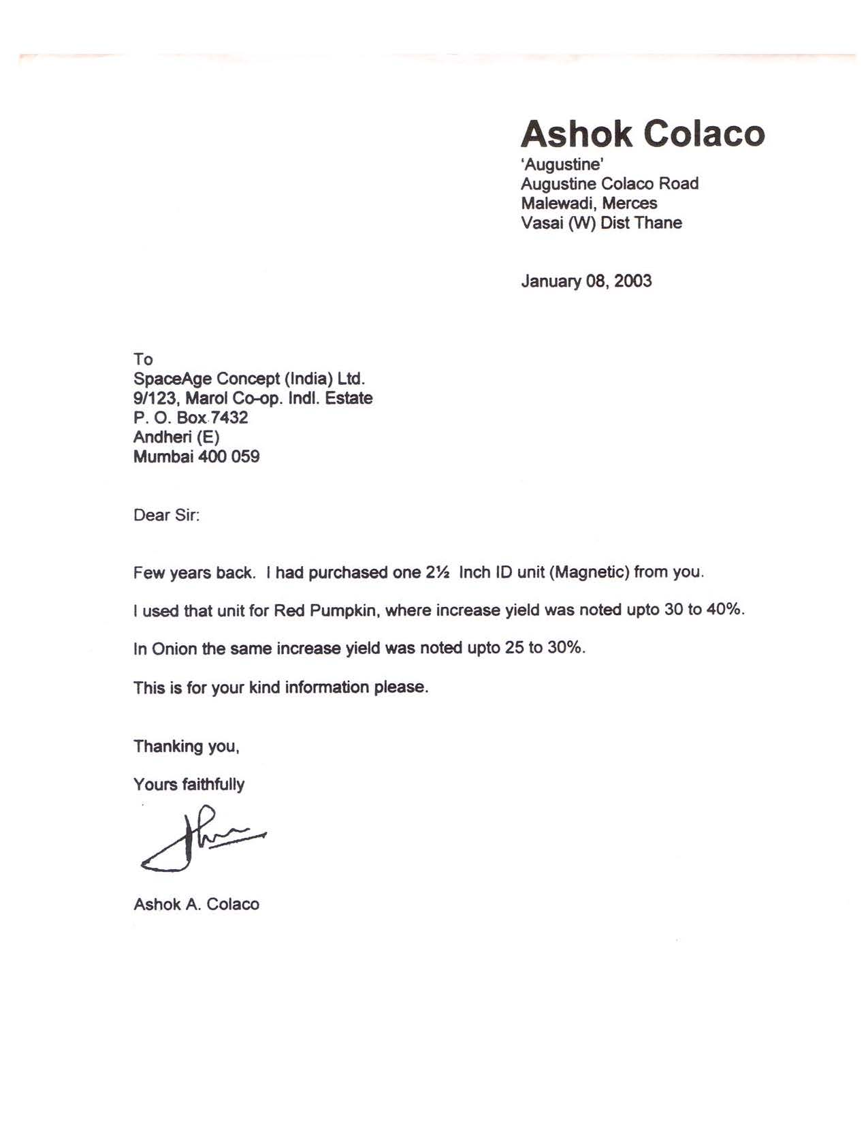

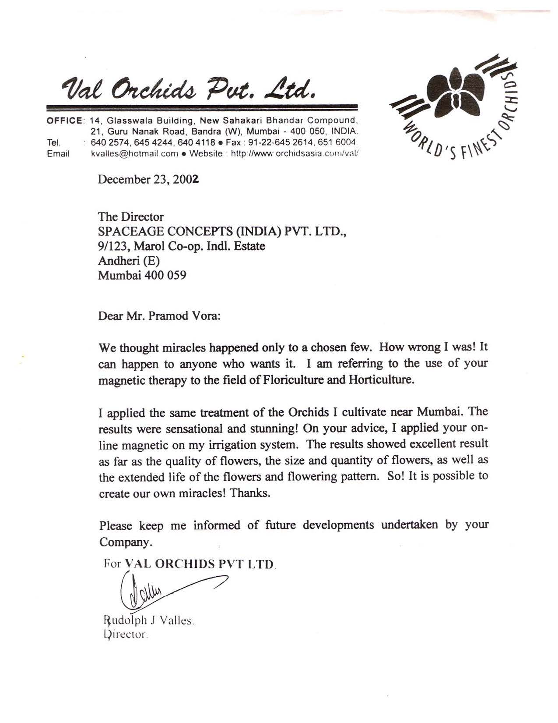

© Copyright 1990 - 2013 SpaceAge ®. All Rights Reserved.
My Posts on LinkedIn – June 2013

Naturally Growing Nutritionally Super Enriched Food
It is now well accepted that the over cultivation of land and the use of synthetic fertilizers has depleted the nutrition in the soil and this has resulted in excessively poor nutritional values in our food supply today.
The resulting consequences are a very high incidence of chronic diseases such as high blood pressure, type 2 diabetes, enlarged prostate, hormone imbalance, etc. Those who have accepted this today as an unavoidable fact of life have resorted to the use of supplements to correct their blood reports, in a bid to live a long and healthy life free of chronic diseases.
The question therefore arises, if there is a natural method to correct the nutritional deficiencies in our soil, so that we need not be compelled to take supplements to survive in this period of time that our generation has to live through.
Not only are there are safe natural methods to achieve the correction of the nutritional values of the soil, but there are techniques to naturally grow nutritionally super enriched foods. How to go about doing this and the science behind it is explained in my paper which was read at an international conference in 2006. A lot of valuable information is given here which will be an eye opener for many. In bid to freely disseminate this information to the masses, I give below the link to download and study this peer reviewed paper and trust it will immensely benefit mankind.
http://www.space-age.com/NutritionalFarmingSeminar.pdf
The problem the world is facing today is bigger than "global warming" (which will affect the future generations to come), as it has already affected billions of people worldwide and will continue to affect the future generations to come, if it is not identified and corrected at this stage. This information needs to be taken viral for saving mankind and improving the quality of the lives of billions worldwide.
Blessings,
Pramod Vora
E-mail: spaceage2008@space-age.com
http://www.facebook.com/pramod.vora100 .
http://www.facebook.com/pages/SpaceAge-Anti-Aging-Center/154567131289336 .
http://www.linkedin.com/pub/pramod-vora/11/89/aa5

Reader’s responses:

Bravo...Your philosophy reminds me of Charles Walters' work about using the minerals from the sea to restore our soils. "Fertility From The Ocean Deep" was one of his works, which I have not read, but is referred to in the one I did pour over, Minerals for the Genetic Code.
Thanks for your thinking outside of the chemical box.
Sandra Lowry, CNC
Certified Nutritional Consultant at Pinnacle Chiropractic & Family Wellness
Rogers, Arkansas , USA

Very informative article which definitely will help to tackle local nutrition problems practically if not totally to some extent.

Shrikant Hiwale
Principal Scientist Horticulture
Central Horticultural Experiment Station, Vejalpur
Vadodara Area, India

Some More Clarifications

The process of transferring nutrients from the soil to the ocean has been going on for millions of years. That is the function of rivers that empty into our oceans. But this does not really deplete the nutrients in the soil in any significant manner, as the running waters also bring fresh silt down the mountains to replenish the soil. Periodic floods also remove the depleted top soil. On their way, the running waters gradually grind down the rocks to make silt. That is way all the rocks on the river bed are always rounded. The pounding of river waters gradually convert the bigger rocks to smaller rounded shapes. In these rocks are stored the minerals required to remineralize the soil. The rocks are very ancient and formed long back and can actually return the soil back today to what it was even a few million years back, and probably even further back to the days of the dinosaurs.

This is exactly what I have proposed in my paper, to use rocks to remineralize the soil. This is very quick and efficient method to correct the problems created in the last century, due to over cultivation of land, use of chemical fertilizers and use of pesticide which have killed the micro-organism responsible for providing nutrients to the plants. In addition, this process will naturally create nutritional super charged food which organic farming does not.

The process outlined by me is far simpler than trying to use salt water to extract the minerals, without adding salt back to soil, as salinity will destroy the soil. It is best to use the ocean water to make mineral rich natural salt and use this salt in its natural unrefined form in our diet to replenish our bodies.

Another method commonly used to bring fresh soil rich in nutrients from deep under to the top is earthworms. These earthworms are capable of bringing fresh soil from a depth of 10 to 15 feet to the top. This is a much slower process, but is also a low cost approach, if a period of rest can be given to the land. This rest period is now difficult to allocate, as we have a worldwide soil depletion and over 7.0 billion mouths to feed.

I would be happy to connect up with some volunteer farmers with depleted farm lands who would begin the process of soil enrichment and growing of nutritionally super charged foods for the masses, to take mankind past the point of organic farming and ensuing chronic diseases such as high blood pressure. type 2 diabetes, etc.

---------------------

For a long and healthy life free from chronic diseases, we have to also ensure that important minerals like magnesium, chromium, selenium, boron, vanadium, molybdenum, .... the list goes on are also replenished back into the soil. This ensures we have a nutritionally rich food supply and can prevent the manifestation of chronic diseases like high blood pressure, type 2 diabetes, enlarged prostate, etc.
Soil remineralization in the quickest way possible is the key to naturally growing nutritionally super enriched food. Use of biomagnetism to treat water will ensure proper uptake of these essential minerals by the roots.

----------------------------
Today we live in a calcium toxic society with calcified arteries, kidney stones, osteophytes, heel spurs, etc.

The role of calcium as a supplement needs to be seriously reviewed.

My recent submissions to the finding of the United States Preventive Services Task Force (USPSTF) on Calcium and Vitamin D can be reviewed by going to:
http://www.space-age.com/USPSTF.pdf

I have also given comments on the Institute of Medicine (IOM) recommendations for calcium at:
http://www.space-age.com/IOM-Findings.pdf

For more information on calcium and osteoporosis please go to:
http://www.space-age.com/osteoporosis.html
Here you will also find case studies on the reversal of osteoporosis without calcium supplements.

A refresher course in undergraduate and postgraduate calcium, magnesium and vitamin D is included for those who are interested to know more about the latest research on calcium and its toxic effects on the human body.

Blessings,
Pramod Vora
E-mail: spaceage2008@space-age.com
http://www.facebook.com/pramod.vora100 .
http://www.facebook.com/pages/SpaceAge-Anti-Aging-Center/154567131289336 .
http://www.linkedin.com/pub/pramod-vora/11/89/aa5

-------------------------

