Healthy Vacations in Mumbai

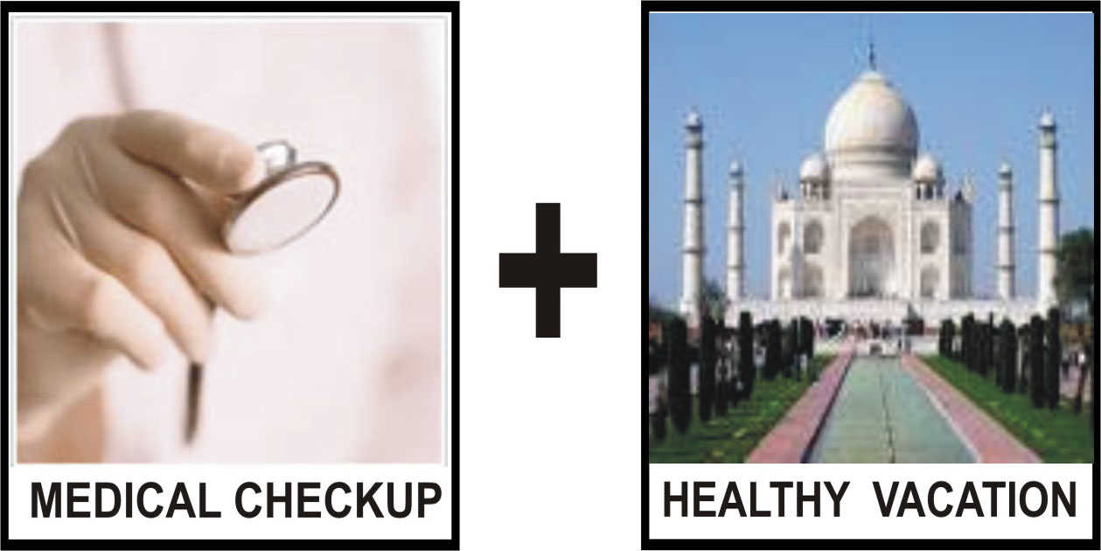

SpaceAge Natural Health Center in Mumbai, (Bombay), India is located within 1 Km (less than 1 mile) from the Sahar International Airport in Mumbai which is the hub of over half a dozen Five Star Hotels like Leela Kempensky, Sheraton, Hyatt, Grand Intercontinental, Meridian to name a few. The Taj Mahal Hotel, Taj Lands Ends, Taj Residency (service Apts.), Oberoi, Grand Hyatt, Intercontinental, are some of the other Five Star Hotels in Downtown Bombay about 30 Km (20 miles) South of the International Airport in Mumbai (Bombay). Map of Clinic is at:
http://www.space-age.com/Mumbai-Clinic-Map.pdf

The Center has over the past several years served as Counselor in Natural Medicine and have been Holistic Educators to both Allopathic (Western Medicine) and Ayurvedic Doctors. The Center presently has over 5,000 Patients and has trained over 1,300 Doctors and successfully treated over 200 Senior Doctors for all kinds of Chronic ailments like Hypertension, Diabetes, Obesity, Arthritis, Migraines, Hormonal Imbalance, Thyroid Diseases, Cardiac problems, Hepatitis, Osteoporosis, to name a few.

The Center has over 200 Celebrities as its Clients. It offers periodic Detoxification & Rejuvenation of the Body, Growth Hormone Therapy for Anti Aging and Reverse Aging and Cosmetic work on each and every aspect of the body. All treatments are done with the use of Safe Natural Herbal / Dietary Supplement only (without any recourse to Botox, Dermabrasion or Plastic Surgery). Focus is on maintaining a State of Perfect Health and Longevity.

The Center has an approximately 85% success rate in cases of Hypertension and Cardiac Diseases and has achieved improvement in Ejection Fraction (LVEF) and has a technology to improve Cardiac function even of a damaged heart with a fair degree of accuracy. The Center has an advanced and elaborate By Passing the By Pass Program for patients desiring to lead a normal life without resorting to Surgical Intervention for removal of Blockages.
Your Quest For Perfect Health Ends Here
The Center is able to reduce the severity and dependency on Insulin for Type II Diabetes patients with a fair degree of accuracy and good success rate.

The Center is able to reduce elevated TSH levels in Hypothyroid patients and Insulin Levels in Obese Patients with a fair degree of accuracy and good success rate.

All treatments are carried out using High Potency Conditioned Herbs and Therapeutic Doses of Intracellular Nutrition as per modern principles of Orthomolecular Medicine.

Please refer Testimonials of Doctors treated at our Center at:
http://www.space-age.com/testimonials.html

The Center offers the following facilities to visitor planning to visit India for Medical Tourism:

- Review of your old Medical Records and past / present medication by our Doctors (preferably prior to your arrival in India) to determine the true state of your health. Modern methods are used to evaluate your Blood Reports based on Internationally accepted Standards of Optimum Values corresponding to perfect health. Consultation Cost is US $70.00 per person.
- Root cause investigation and Root Cause diagnosis of all your chronic medical problems based on your Medical History and present symptoms.
- Complete Detoxification and Rejuvenation of Colon, Kidneys, Liver, Lungs, Blood (preferably 4 to 8 weeks prior to your arrival in India) by means of a user friendly Do It Yourself Kits which comprises of Safe Natural Herbal / Dietary Supplements. Each Program lasts approximately 4 weeks. Cost US $ 125.00 each for Detoxification and Rejuvenation Kit respectively. For more information please access:
http://www.space-age.com/detox.html

- On your arrival in India the following is carried out:
  - Evaluation of your Cardiac function and Ragland Postural Measurements to determine the state of your Cardiac Health / Adrenal Function. Check up for missed Heart Beats.
  - Complete Body Scanning on a special Microprocessor Controlled Electronic Machine to determine – Weight, Fat Mass, Bone Mass, Hydration Level / Water Retention, Average Calorie intake and Metabolic Age of the Body
  - Measurement of Body pH to determine the level of acidity in your Blood.
  - Evaluation of your present diet pattern and recommendations for any changes if required. Cost of above Consultation lasting approximately 1 hour is US $100.00 per person.

- Next day a complete evaluation of your Health by a Comprehensive Health Check Up Program. Time required: approximately 1 day. The following Tests are conducted:
a) Laboratory Tests – Complete Blood Count, ESR, Urine / Stool Examination
b) Tests for Diabetes – Fasting and Post Breakfast Blood Sugar
c) Tests for Kidney Function – BUN, Uric Acid, Creatinine, Serum Sodium, Potassium, Chlorides and Phosphorous
d) Tests for Cholesterol / Lipids – Cholesterol, HDL, Triglycerides, Ratios, LDL Cholesterol, VLDL Cholesterol, Cholesterol/HDL Cholesterol Ratio
e) Tests for Liver Function – Bilirubin, SGPT (ALT), SGOT (AST), Gamma GT (GGTP), Alkaline Phosphatase, Total Proteins (Albumin and Globulin)
f) Special Tests – Serum Calcium, Acid Phosphatase, HBsAg
g) Tests for Heart Disease - Risk Factor Review, ECG, Stress Test (Tread Mill)
h) Sonography – Abdominal Organs, Prostate Scan for Males, Ovaries/Uterus Scan for Females
i) X-Ray Chest
j) Eye Check-Up – Fundoscopy, Tonometry, Refraction Error By Opthalmologist
k) Women’s Check-up – Gynaecological Exam, PAP Smear Test
l) Spirometry – Lung Function Test
m) Dental Check-Up – Dental And Oral Cancer Check-up
Complete Reports are available within 2 to 3 days. Cost US $ 200.00 per person.

Optional Tests which can be done simultaneously on the same day:
- EEG
- 2D Echo (Digital)
- Color Doppler (Digital)
- CT Scan
- Wide Open MRI
- PFT, Audiometry
- Mamography for Females
- PSA for Males
- Thyroid Free T3, Free T4, Ultrasensitive TSH
- HIV Test ELISA
- 2D Echo Color Doppler for Heart
- Glycosylated Hemoglobin for Diabetes
Optional Tests are at an additional cost not mentioned above.

- Additional Blood Tests to evaluate Hormonal and Nutritional Imbalance and Heavy Metal Toxins. Time required: 1 day. Cost can vary from US $100 to US $ 500.00 maximum depending on the number of Blood Tests relevant and chosen as per each person’s requirements and desire during Consultation. Blood sample is collected from your Hotel Room and Reports are normally available within 3 to 5 days. Heavy Metal Toxin Reports normally require 10 days.
Combine Vacation With Your
Quest For Perfect Health & Body !
- Additional Blood Tests for:
  - Cardiac Risk Profile – US $120.00
(Homocysteine, Lp(a), D-dimer, hs CRP, LDL, direct Apolipoproteins, A1(b)
  - Cardiac Injury Profile – US $ 140.00
(Includes CK-MB, FABP, Glycogen Phosphorylase, Myoglobin, Troponin-l
  - Diabetes Risk Profile – US $ 100.00
CBC, FBS, PPBS, Cholesterol, Triglycerides, Creatinine, Electrolytes, Urine routine, Insulin antibody, Microalbumin, Insulin, C-peptide, HbA1c)
  - Infertility Profile (Male) – US $ 100.00
  - Infertility Profile (Female) – US $ 90.00
Can be carried out simultaneously with the above Test with no further expenditure of time. Additional Cost: as shown above.

Details of all Blood Tests in each category above are given in Annexure I.

Once all the Reports are ready and gone through by our Panel of Doctors, a further 1 hour Consultation is offered to suggest ways and means to correct and improve upon the deficiencies in these Reports in a short 8 to 12 weeks time. We also offer Root Cause Investigation, Diagnosis and Treatment for all Chronic Health Challenges. All “Mission Impossible” of Medical Science are welcome. Cost US $100.00 per hour per person.

During this Consultation, Future Goals for a Perfect Health and Body are defined and an action plan is custom designed in conjunction with each person’s requirement for ways and means to achieve the same. An action plan is drawn up for achieving a State of Perfect Health and Perfect Body in the near future.

The Center will draw up a Protocol of Treatment and an easy to follow Daily Calendar to guide you for a Safe Natural Treatment using only Herbs and Dietary Supplements. No Drugs or Chemicals are used to help you overcome or reduce the severity of any Chronic Health Challenge. Follow up weekly support by E-mail and Telephone is offered for implementation during your stay in India and for continuation upon your return back to your country. Cost typically varies from US $100.00 to $1,000.00 depending upon the severity of the Chronic Ailments involved and the response of each person concerned.

A Do It Yourself user friendly Detoxification / Rejuvenation Kit is offered for your use after returning back to your country. This comprises of a safe Natural Herbal / Dietary Supplements to be taken orally for improving the functioning of your Colon, Kidneys, Liver, Lungs, Blood and overhauling your entire body to make it run at peak efficiency. This leaves a Healthy Goal on your face which your friends can’t help noticing.

Reservation in 4 to 5 Star Hotel / Service Apartment in Mumbai (Bombay), India. Sight seeing / shoping in Mumbai during your stay here.

Combine Vacation With Your
Quest For Perfect Health & Body !
4 to 10 day trips can be arranged to neighboring towns and cities of your choice – Udaipur, Jaipur, Agra (Taj Mahal), New Delhi.

Relaxation Herbal Body Massages are offered for the treatment of Body Aches, Pains and other problems.

Stay in Ayurvedic Health Resorts in Kerala.

Consultation / Treatment with reputed Doctors for all kinds of Cosmetic work / Plastic Surgery, Dental and Eye (Lasik) Treatment can be arranged. Visit to Optomerist for Eye Glasses can be arranged.

Consultation with Cardiologist for Angiography, Angioplasty and By Pass Surgery can also be arranged.

The Center has Protocol to boost the Immunity of AIDS, Hepatitis and Herpes Patients and to improve the quality of their life and longevity.

General Information for Tourists:
Cost of Air Travel from the West Coast to Mumbai, India is roughly US $ 1400.00 to US $1800.00 per person traveling by Economy Class via the Atlantic on British Airways, Air France, Swiss Airlines, Lufthansa with transit stop in London, Paris, Zurich and Frankfurt respectively. With a quick connection – wait typically 2 to 3 hours.

Cost of Air Travel from the West Coast to Mumbai via the Pacific with transit stop in Hong Kong, Singapore, Seoul is roughly US $ 1200.00 to $1600.00 on Singapore Airlines, Cathy Pacific and Korean Airlines.

Cost of Hotel Rooms in Mumbai (Bombay) as approximately as follows:
4 Star Hotels - $125 to $200 per night for Double Occupancy
5 Star Hotels - $250.00 to $450.00 per night for Double Occupancy

Combine Vacation With Your
Quest For Perfect Health & Body !

The Government of India provides Tourist Visa of short duration and a special Medical Tourism Visa (M) of longer duration (up to 1 year) for persons and Visa (MX) for their accompanying spouse coming to India for Medical Treatment. Please contact the nearest Indian Consulate in your country of Residence or go to:
http://www.goidirectory.nic.in/missions.htm
for a directory giving a list of Indian Missions worldwide.

SpaceAge®
Natural Health Center
9/123 Marol Co-operative Industrial Estate
Marol Sag Baug, Andheri (East)
P. O. Box 7432, Mumbai 400 059
INDIA
Tel: 91 – 22 – 2852-6564 (for Consultations / Appointments)
Tel: 91 – 22 - 2850-3986 / 2850-8653
Fax: 91 – 22 – 2850-6214
E-mail: consult@space-age.com
Internet: http://www.space-age.com

Your Quest For Perfect Health Ends Here

