SpaceAge ®

Natural Health Center
# 9/123 Marol Co-op. Industrial Estate
P. O. Box 7432, Marol Sagbaug
April 15, 2002 Andheri (E), Mumbai 400 059
Tel: 2850 - 8653 / Fax: 2850 - 6214
 spaceage@space-age.com
 http://www.space-age.com

Subject: Sequel to Use of Antibiotics for Colds & Sore Throat

Dear Health Practitioner:

Low Immunity is the prime reason why some people constantly catch Colds / Sore Throat and other infections.

Rather than administering Antibiotics in such situations, it is always better to explore the possibility to improve the Body's own immunity. As I wrote earlier, regular use of Antibiotics ends up only in lowering the immunity further. So, it cannot be considered as a good, long term Health Care option for routine or prolonged use.

One of the factors, governing low immunity, is pH (potential Hydrogen or number of Hydrogen Ions or Acidity) of the Body. The Natural pH of a healthy body, free of any disease, is always slightly Alkaline at a pH of 7.4.

When the Body becomes acidic at the cellular level, it creates a breeding ground for germs, bacteria, and other micro-organisms. These can only flourish and multiply in an acidic environment.

If the fluids of the Body (Blood, Saliva, etc), are maintained Alkaline, it will be well nigh impossible for these organisms to multiply or even survive.

Our Health Center provides a pH Test Kit to determine the pH of the fluids in the Body by simply testing the pH of the Saliva. There exists a very good co-relation between the pH of the Saliva and other body fluids, like the blood for instance.

We also have a Dietary Supplement called AlkaBoost which helps to rapidly adjust the pH of the Body and maintain it at an Alkaline level.

For more information on pH Imbalance and AlkaBoost, please visit our Website on the Internet at: http://www.space-age.com/alkaboost.html

It is noteworthy, to remember that, Cancer cells do not easily multiply in an Alkaline environment. Controlling and regulating Body pH is one of the safest non-invasive techniques of reducing the risk of Cancer or controlling or curbing or slowing down Cancer Cell proliferation in the Body.

Another technique to improve the immunity of the Body, is to use a Natural Antibiotic like Mono Atomic Silver. This is a colloidal form of Silver suitable for oral and topical applications. When administered orally, it can boost the Immunity of the Body. Atomic Silver has been tested in UCLA School of Medicine, California against 650 known pathogens, microorganisms, bacteria, fungi (including Candida Albicans and Candida Globata), protozoa and viruses. In comparison, regular Antibiotics are perhaps effective only against half a dozen organisms. Mono Atomic Silver has also been used to improve immunity of AIDs patients. It has no side effects as it is Bio-compatible with the human body. It also has strong Antiviral properties. It is a very low cost solution to costly Antibiotics. Mono Atomic Silver is available from our Center in convenient 250 ml and 500 ml bottles. SpaceAge Laboratories have evolved a portable pocket sized and a Desktop instrument for your Clinic / Hospital, which can, within seconds, produce a glass or a liter of Mono Atomic Silver respectively. It is a low cost Natural Antibiotic which is very ideally suited for treatment of the masses of a low cost economy like India which live below poverty level.

Remember, a healthy body always has higher immunity. Eating Nutritionally and pH Balanced Meals can also go a long way to help raise and maintain the Body's immunity.

Continued on Page 2 ...

Health Care - Naturally !

Page 2

Use of Herbal Dietary Supplements and Bio-Magnetic Devices to enhance the functioning of the Thymus Gland can also increase the production of T-cells and improve the Body's Natural Defense Mechanism. Info at: http://www.space-age.com/thymus.html

Improving immunity, to prevent infections, is a safer and naturally a more harmonious way of maintaining the human body in balance. Trying to remove an infection once it has invaded the body, by trying to "kill germs" with Antibiotics can only create an imbalance in the Body and weaken it further. Regular Antibiotics being "Dumb Chemicals", kill everything in sight - friends and foes. They destroy the infection causing germs as well as the healthy bacteria required for digestion which work as Probiotics in the human body. This ends up lowering the immunity, forcing the Body into a perpetual and vicious cycle of repetitive infections coupled with still lower immunity at the end of each cycle. (Probiotics besides aiding digestion, prevent the overgrowth of yeast and other pathogens and help in synthesizing Vitamin K required for the reversal of Osteoporosis. More on Probiotics in my next circular to you.)

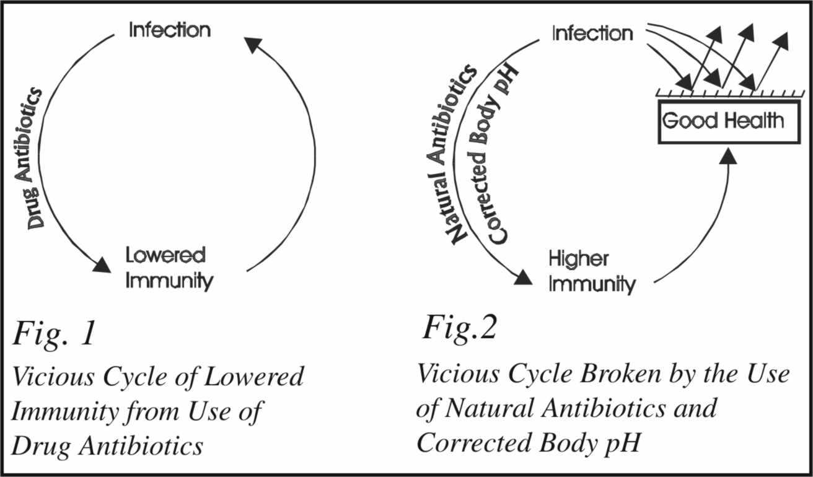

The Body weakens further with each cycle and the germs develop further resistance and immunity with each onslaught of Antibiotics. Remember, the germs also have intelligence and they will continue to evolve (develop resistance) to fight their destruction due Bio-Chemical Warfare that you would like to conduct on the human body. The stage is now set for diseases like Candida, Colon Cancer, etc to invade and permanently reside in the Body, speedily taking it to its final destruction and premature death.

The number of Antibiotics capable of controlling infections, are diminishing rapidly, due to the indiscriminate and repetitive use of Antibiotics. The day is not far away, when the Pharmaceutical Industry may be unable to offer newer and more powerful Antibiotics. The strength of the Antibiotics now being used has grown to such an extent that their after effects linger on in the body for days after their use has been stopped. Replacing the friendly bacteria lost from the body is getting more difficult with each passing day. The present typical Therapeutic Dose of Lactobacillus Acidophilus is 1.0 Billion living organism to be taken twice a day for at least 10 to 15 days after completing the Antibiotic course. As you know, such Therapeutic Doses are presently not available at the Chemists; so correction of the damage done by Regular Antibiotics becomes an uphill task. The Body then becomes unbalanced and depleted of its internally manufactured B-Complex Vitamins. Therapeutic doses of B-Complex, as per US Standards, not being readily available, sets the ground work for a host of Chronic Ailments to invade and begin destroying and rapidly aging the body.

Please protect the environment and your Body by minimizing the use of these dangerous Antibiotics.

Blessings and Good Health,

Pramod V ora
Natural Health Counselor

Health Care - Naturally !

